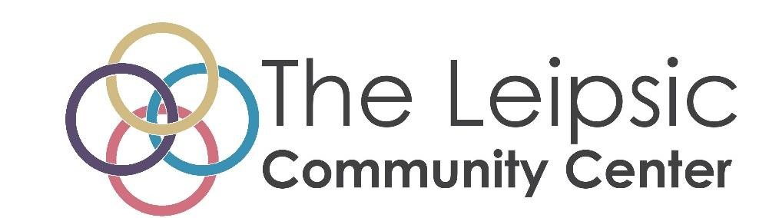
Fall/Winter Craft Show
Saturday October 28, 2023
9:00am-2:00pm
Vendor Application

Please email to: director@theleipsiccenter.org or send to: The Leipsic Community Center
120 E Main St., PO Box 63
Leipsic, Ohio 45856

Business or Organization: ________________________________
Contact Person: ________________________________________

Address: ______________________________________________
City, State_____________________________________________

Phone: ________________________________________________
Email: ________________________________________________

Check box if need access to electricity (there is a $10 additional fee)

Description of business__________________________________________________________
_____________________________________________________________________________ _____________________________________________________________________________ _____________________________________________________________________________
_____________________________________________________________________________

Policies and Regulations

- Each booth space in the gym is 10 x 10. You must supply your own tables. We have chairs available.
- In the event that all 10 x 10 booths are filled in the gym, additional booth space/sizes will be made available throughout the community center.
- Maximum of three 8’ tables allowed in the10’x10’ booths. You will receive a floor plan of the setup area and instructions as to how tables must be arranged.
- Rent is $35 for a booth. No space is reserved unless payment has been received. There is a $10 additional fee for booths with electricity.
- You will receive an assigned numbered booth when registered
- You may set up Friday evening from 5pm-6pm, and/or Saturday morning from 7:00 am to 8:30 am
- Space is first come/first serve. Deadline to register is October 13, 2023.
- Categories will be limited to assure a proper balance
- All pertinent fire codes, laws, ordinances and regulations pertaining to health, fire prevention, and public safety shall be strictly obeyed
- Insurance, if desired by you, must be obtained at your own cost and expense. The promoter, The Leipsic Community Center, assumes no risk; and by acceptance of this agreement, the exhibitor and associates expressly release the promoter, The Leipsic Community Center, from any and all liability
- Exhibitors must notify The Leipsic Community Center in case of cancellation. There is a 50% cancellation fee prior to October 13, 2023 and then no refunds after this date.

I certify that I have read this contract and understand and agree to all terms.

Signature_______________________________________ Date________________

